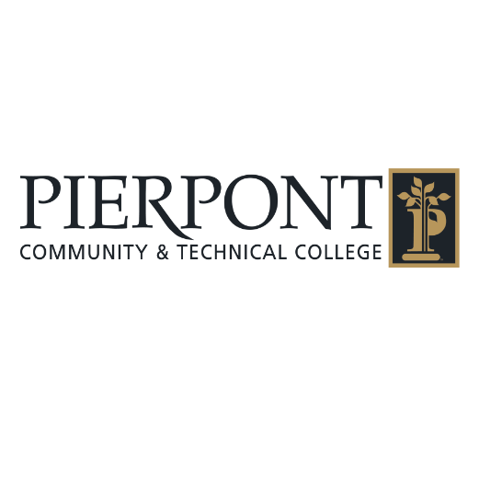**Housekeeping**

*Effective: 5/2025*

### **Purpose**

The purpose of this housekeeping policy is to maintain a clean, safe, and sanitary environment at Pierpont Community and Technical College (PCTC). This policy outlines the responsibilities and expectations for all staff, faculty, and students to ensure a well-maintained campus.

### **Scope**

This policy applies to all campus facilities, including classrooms, offices, hallways, restrooms, common areas, outdoor spaces, and any other areas under the jurisdiction of PCTC.

**General Guidelines:**

1. **Cleanliness and Maintenance**
   * All campus facilities must be cleaned and maintained regularly to ensure a safe and healthy environment for all individuals.
   * The Facilities Department is responsible for the regular cleaning and maintenance of public and administrative spaces.
   * Employees and students should report any cleaning or maintenance issues (e.g., spills, broken furniture, equipment malfunctions) to the Facilities Department in a timely manner.
2. **Classrooms and Offices**
   * Faculty and staff are encouraged to maintain their workspaces in an organized and tidy manner.
   * Personal items should be stored appropriately and not obstruct walkways or emergency exits.
   * Waste bins should be used to dispose of paper, food, and other waste, and should be emptied regularly.
3. **Restrooms and Common Areas**
   * Restrooms must be stocked with necessary supplies (toilet paper, soap, hand dryers, etc.) and cleaned on a regular schedule.
   * Students, faculty, and staff are expected to help maintain the cleanliness of restrooms by properly disposing of paper towels and other waste materials in designated receptacles.
   * Any restroom maintenance issues, such as plumbing or sanitation concerns, should be reported to Facilities immediately.
4. **Waste Disposal**
   * Proper waste disposal is essential for maintaining a clean environment. All individuals on campus are expected to use the correct waste containers for recyclable and non-recyclable materials.
   * Recycling bins must be clearly labeled, and efforts should be made to minimize waste and maximize recycling on campus.
   * Trash should be disposed of in appropriate containers. Overflowing trash bins should be reported to Facilities.
5. **Outdoor Areas and Grounds**
   * Littering is prohibited on campus. Students, faculty, and staff should dispose of waste in the designated trash and recycling bins.
   * The Facilities Department will ensure that the grounds are maintained, including landscaping, sweeping, and snow removal (if applicable).
   * Individuals should report any hazardous outdoor conditions, such as unsafe walkways or damaged benches, to the Facilities Department.
6. **Hazardous Materials**
   * All hazardous materials (e.g., cleaning agents, chemicals, etc.) must be stored in designated areas and handled in accordance with safety regulations.
   * Students and staff should follow proper procedures for disposing of hazardous materials, including any chemicals used in classrooms or labs.
7. **Health and Safety**
   * All cleaning products must be EPA-approved and used in accordance with health and safety guidelines.
   * The college will make efforts to use green cleaning products where possible to minimize environmental impact.
   * In the event of a health or safety issue (e.g., spills, broken equipment), the Facilities Department will take immediate action to resolve the situation.
8. **Special Events and Classroom Changes**
   * For special events, conferences, or large gatherings, the Facilities Department will coordinate extra cleaning and maintenance needs.
   * Faculty and staff who schedule events or classes that require room setup or cleanup should notify Facilities well in advance to allow for adequate planning.
9. **Responsibilities of Students and Faculty**
   * Students are responsible for keeping personal items in an orderly manner and disposing of waste in appropriate bins.
   * Faculty and staff should ensure their work areas remain clean and organized and promptly report any issues that require attention.
   * Eating should be done in designated areas only, and students should avoid leaving food waste in classrooms or hallways.
10. **Compliance and Enforcement**

* All individuals on campus are expected to comply with PCTC’s housekeeping policy. Failure to maintain cleanliness and hygiene can result in disciplinary action, depending on the severity of the issue.
* The Facilities Department will conduct periodic inspections to ensure the campus remains in good condition.

**Conclusion:**

A clean and well-maintained campus is essential for the well-being and success of PCTC. By following this housekeeping policy, all individuals contribute to a productive, safe, and welcoming environment. Cooperation between students, faculty, staff, and Facilities will ensure a consistent and high standard of cleanliness across campus.