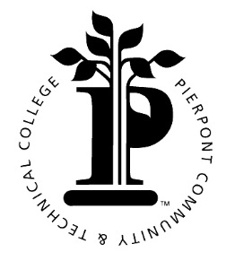Pierpont Community & Technical College

500 Galliher Drive

Fairmont, WV 26554