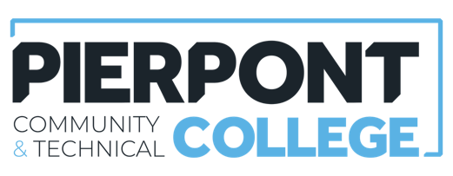
Facilities Help Desk Policy

Effective: July 2026

Purpose
The purpose of this policy is to establish a standardized process for requesting maintenance, repairs, custodial services, facility improvements, and other facility-related services through the Facilities Help Ticket System which can reached by emailing facilities@pierpont.edu

Scope
This policy applies to all Pierpont Community & Technical College employees and all College-owned or leased facilities.

Policy

Policy Statement:

All non-emergency facility-related requests shall be submitted through the College's Facilities Help Ticket System. (see Emergency Procedures below)

Types of Requests:

Maintenance, custodial, grounds, safety, and facility improvement requests.

Submission Requirements:

All requests must be emailed to: Facilities@pierpont.edu

Employees shall provide name, department, location, description of issue, date discovered, photographs when applicable, and contact information.

Request Prioritization:

Requests shall be categorized as Emergency, Urgent, Routine, or Project Requests.

Emergency Procedures:

Employees must immediately contact Campus Security and/or Facilities personnel for emergencies and then submit a help ticket as soon as practical.

Approval Requirements:

Certain requests may require supervisory, departmental, or administrative approval before work begins.

Employee Responsibilities:

Employees are responsible for submitting complete and accurate requests and providing access to affected areas.

Facilities Department Responsibilities:

Facilities shall review, prioritize, assign, track, and document all work requests.

Ticket Closure:

Tickets may be closed when work is completed, resolved, or determined to be outside the scope of Facilities services. If it is outside the scope of the facilities, then an outside contractor may have to be contacted. The requestor will be notified of the appropriate course of action that will be taken.

Record Retention:

Records shall be maintained in accordance with applicable College retention requirements.

Compliance:

Employees are expected to utilize the Facilities Help Ticket System for all non-emergency requests.
Questions regarding this policy should be directed to the Manager of Safety, Security, and Facilities.

