Joining Zoom Meeting via Web Browser
- Open Browser.
- Go to join.zoom.us.
- Enter your meeting ID provided by the host/organizer. This will be a 9, 10, or 11-digit number
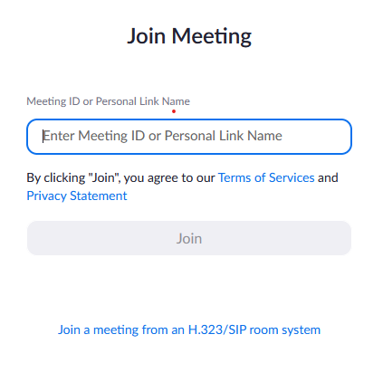
- Click “Join”.
- Click “Launch Meeting”
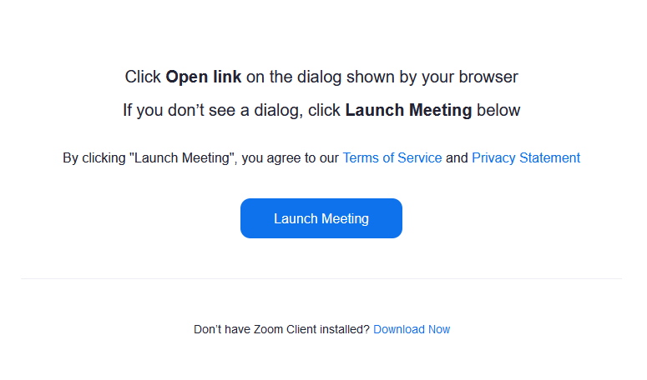
After clicking launch meeting, a join from Your Browser link should appear
- Click “Join from Your Browser”.
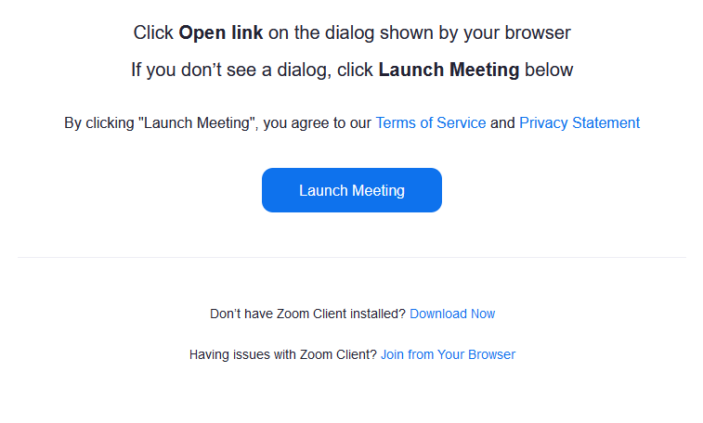
There should be a popup near the top of your browser verifying you want to give Zoom access to your Camera and Microphone.

- Verify your camera and microphone setting in the popup then press “allow”.

You should now see your video and see the microphone light up when you speak.

- Enter your name in the “Your Name” box

- Click “Join”

The host can have a passcode enabled, if you see a screen asking for a passcode please ask the host to provide the code for you.
Otherwise, the host can admit you into the call.

